

BIT3208: Advanced Web Design and Development

Mount Kenya University

Hospital Ward Management System
Weekly Practical Logbook
Student Name: Lewis Leshan
Admission Number: BSCCS/2024/74848
Course/Class: Computer science
Unit Code: BIT3208
Unit Name: Advanced Web Design and Development
Lecturer Name: Michael Nyoro
Semester/Academic Year: Year 3 Sem 2
GitHub Portfolio: https://github.com/lewiiileshan/Hospital-ward.git
Figma Link: https://www.figma.com/make/nSUi1JkvdNhJoEpTBSrvA9/Design-hospital-ward-layout?t=JwJco84ng5xCASoW-1

Project Title: Hospitalward
Selected Technologies: PHP + MySQL, Figma, HTML + CSS,

Table of Contents
Week 1: Local Environment Setup 3
Required Evidence 3
Figure 1: 4
Figure 2: 4
Figure 3: 4
Figure 4: 5
Figure 5: 5
Student Reflection 5
Week 2: Wireframes and GUI Design 6
Required Evidence 6
Figure 1: 6
Figure 2: 7
Figure 3: 8
Figure 4: 9
Figure 5: 9
Student Reflection 10
Week 3: JavaScript Validation and PHP Basics 11
Required Evidence 11
Figure 1: 11
Figure 2: 12
Figure 3: 13
Figure 4: 13
Figure 5: 14
Student Reflection 14
Week 4: Backend Authentication System 15
Required Evidence 15
Figure 1: 15
Figure 2: 15
Figure 3: 16
Figure 4: 16
Figure 5: 17
Student Reflection 17
Week 5: Database Integration and CRUD Operations 18
Required Evidence 18
Figure 1: 18
Figure 2: 19
Figure 3: 19
Figure 4: 20
Figure 5: 20
Figure 6: 20

Week 1: Local Environment Setup

Required Evidence
Installation of XAMPP

Figure 1:

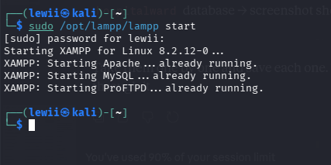

XAMPP and MySQL services running (terminal output)

Figure 2:
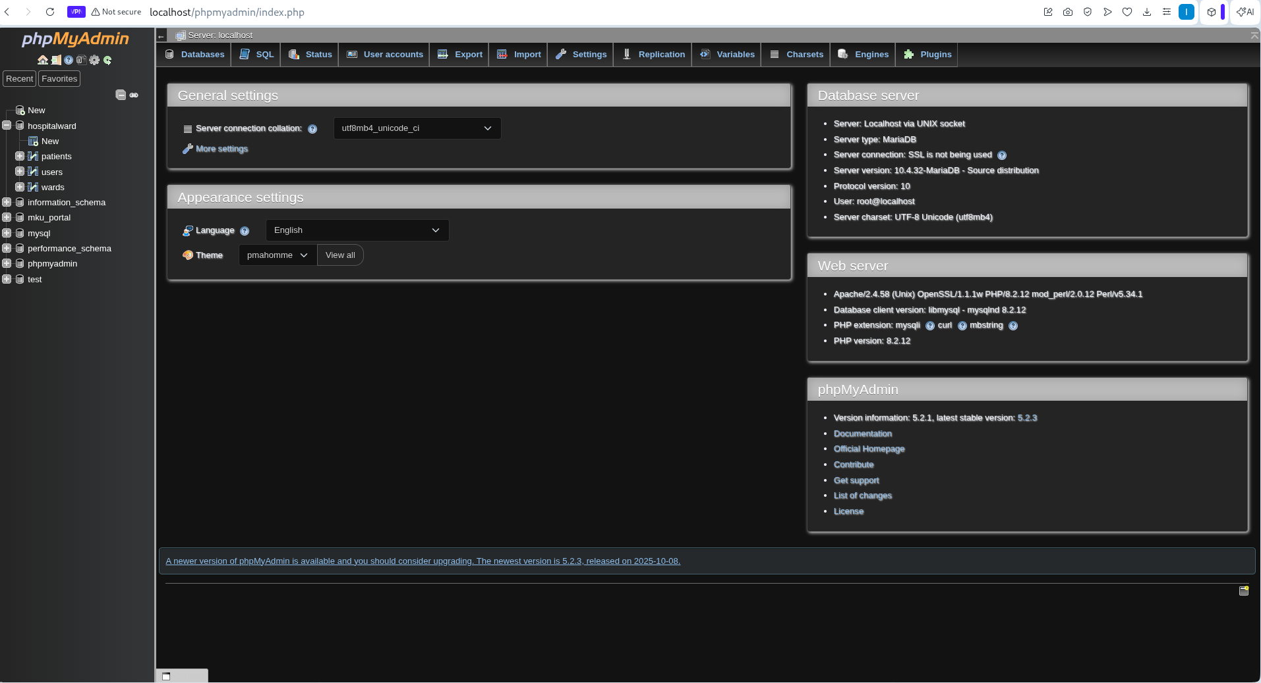
Browser showing phpmyadmin dashboard confirming Apache is serving pages

Figure 3:

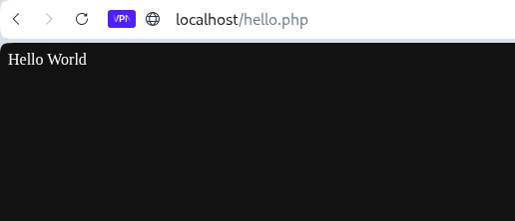
Hello World test page running successfully

Figure 4:

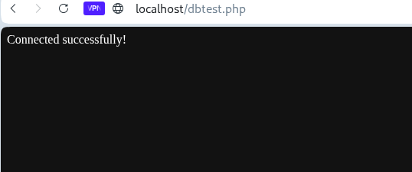
PHP-MySQL connection test -page confirming successful database connection

Figure 5:

Student Reflection
This week I set up my local development environment. I installed and configured XAMPP on Kali Linux and verified that Apache and MySQL services were running. I tested the localhost server by creating a simple PHP Hello World page. I then opened phpMyAdmin and confirmed the database server was accessible. The connection test using PDO in PHP confirmed that the backend environment was ready for development. This setup is the foundation for all subsequent development work.

Week 2: Wireframes and GUI Design

Required Evidence

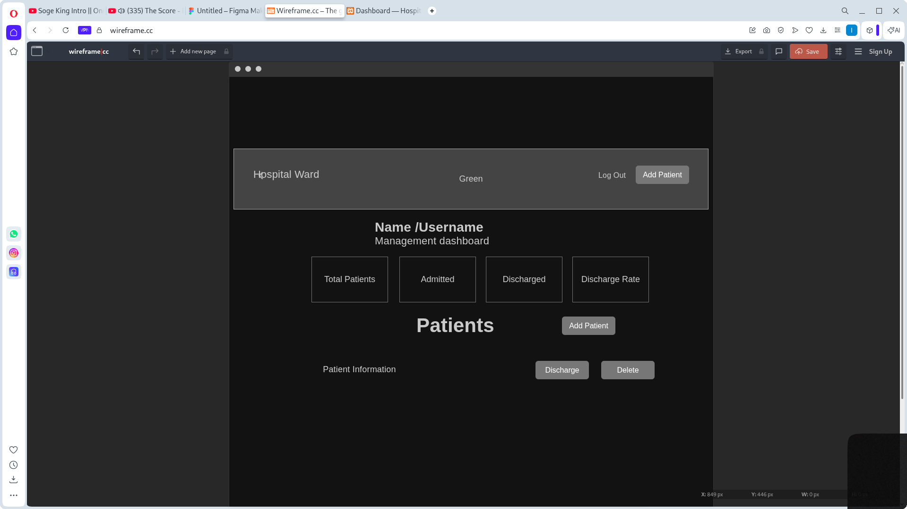
Wireframe of the Dashboard page showing form fields and layout

Figure 1:

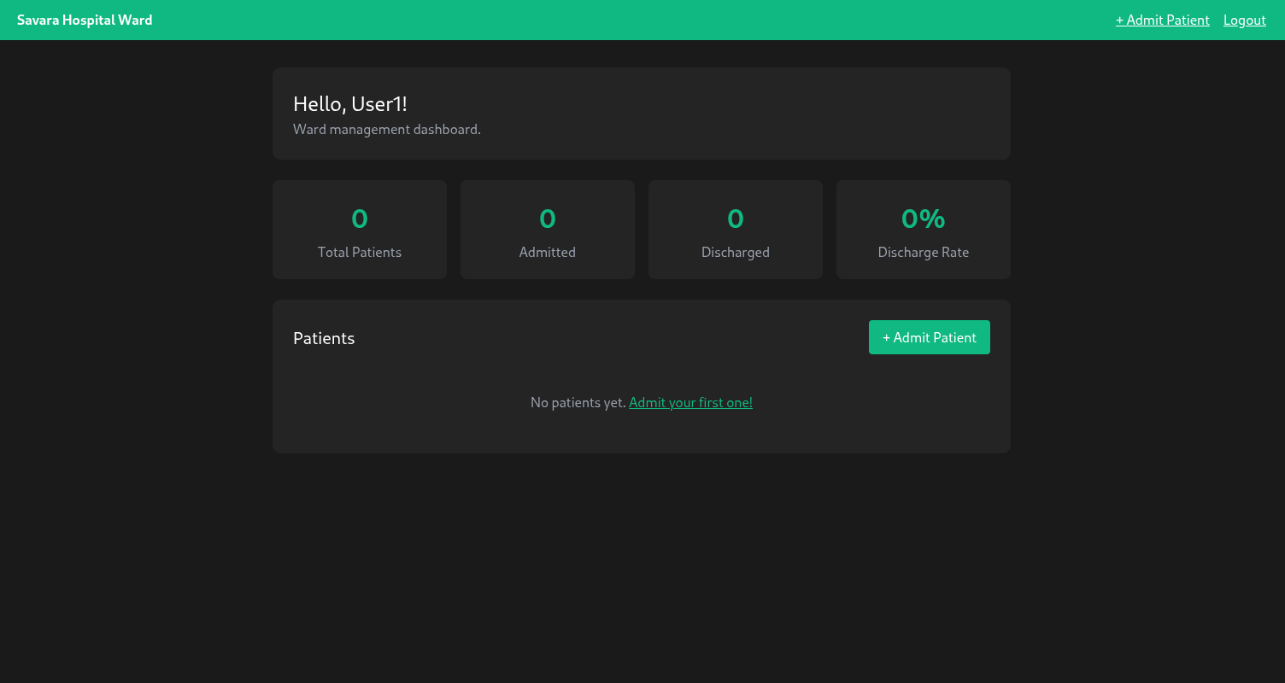
Hello World test page running successfully

Figure 2:

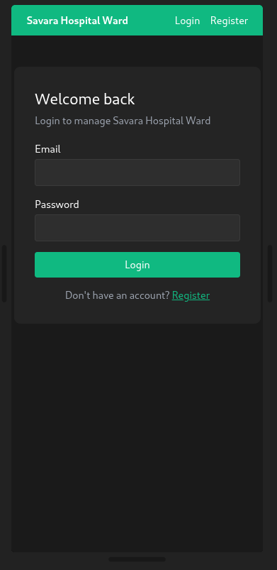

Mobile view of the login page

Figure 3:

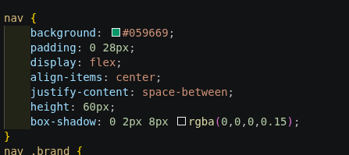

Colour Scheeme choice is green and White/Black

Figure 4:

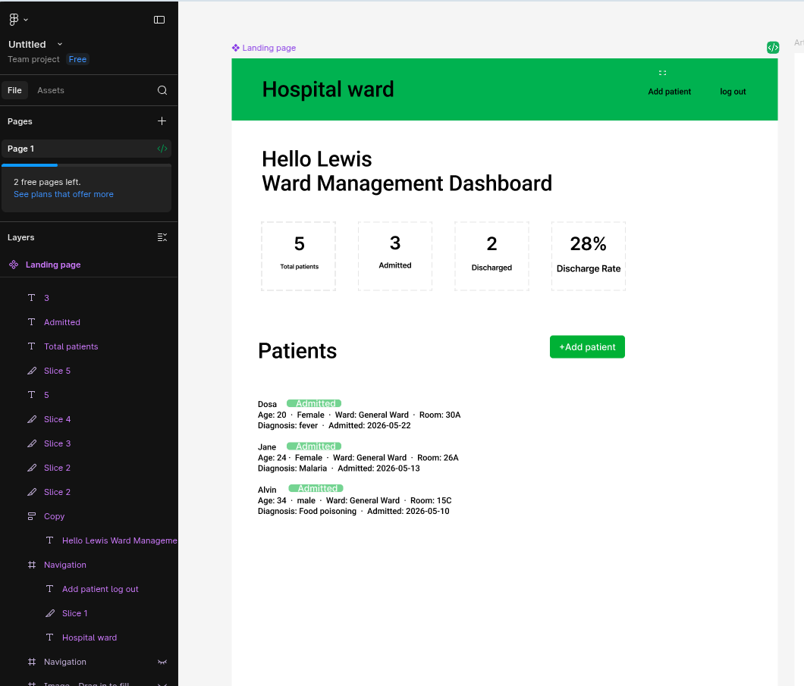
Digital Mockup/ Figma system UI

Figure 5:

Student Reflection
This week I planned the visual design of the Hospital Ward Management System. I drew wireframes for three main pages: the login/register forms, the patient dashboard, and the add patient form. Green was selected as the primary color to reflect a medical/health theme. The dashboard layout was designed to display patient information clearly with action buttons on the right.

Week 3: JavaScript Validation and PHP Basics

Required Evidence

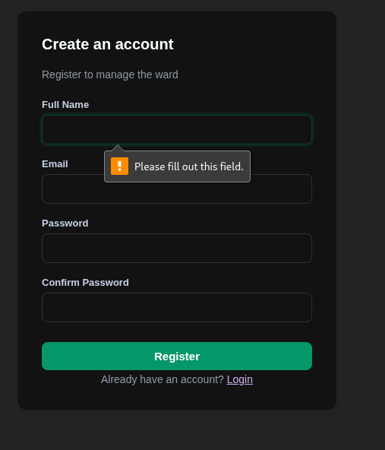

JavaScript form validation on the registration form preventing empty submissions

Figure 1:

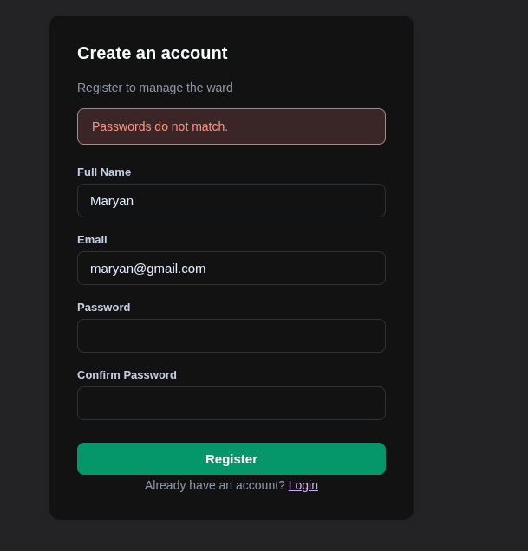
Password mismatch error shown when confirm password does not match

Figure 2:

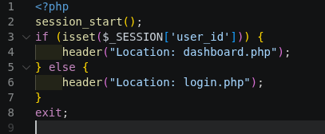

PHP syntax practice -simple variable echo and conditional statement output

Figure 3:

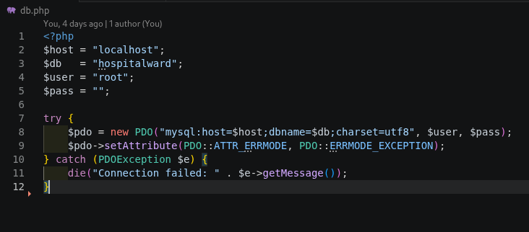
db.php code and successful database connection output in the browser

Figure 4:

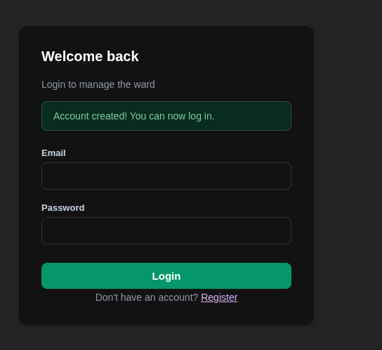
Dynamic PHP page displaying user-submitted form data back on screen

Figure 5:

Student Reflection
This week I practiced JavaScript and PHP basics. I added client-side validation to the registration form to prevent empty fields from being submitted. I also added a password confirmation check. On the PHP side, I practiced outputting variables, using conditionals, and processing POST form data. I wrote the db.php using PHP's PDO library to connect to the MySQL database. The connection was confirmed to work perfrctly.

Week 4: Backend Authentication System

Required Evidence

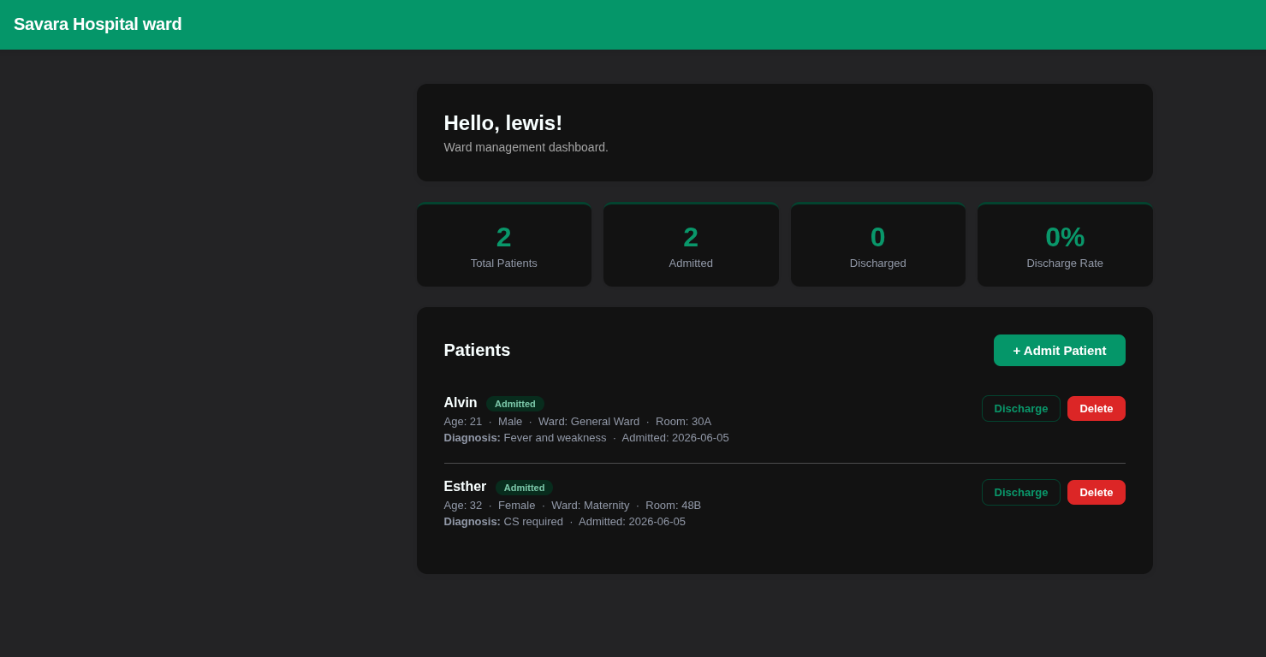
Dashboard page showing the username feedback from login

Figure 1:
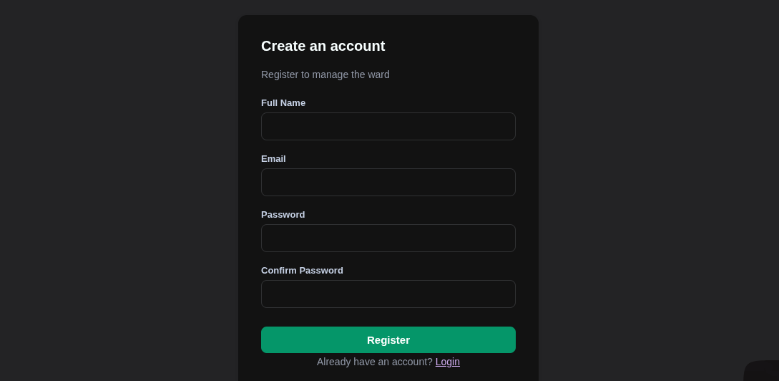

Registration form with all fields required

Figure 2:

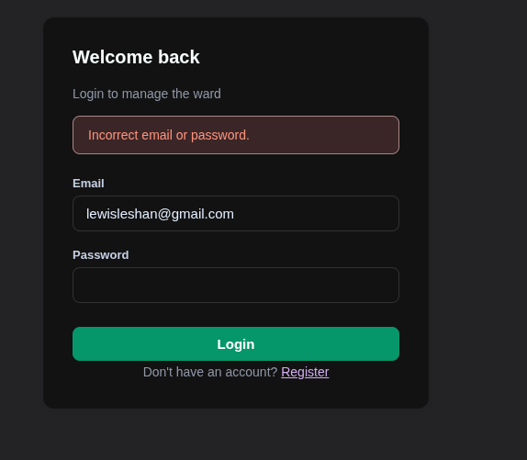
Error message shown on login page when wrong credentials are entered

Figure 3:

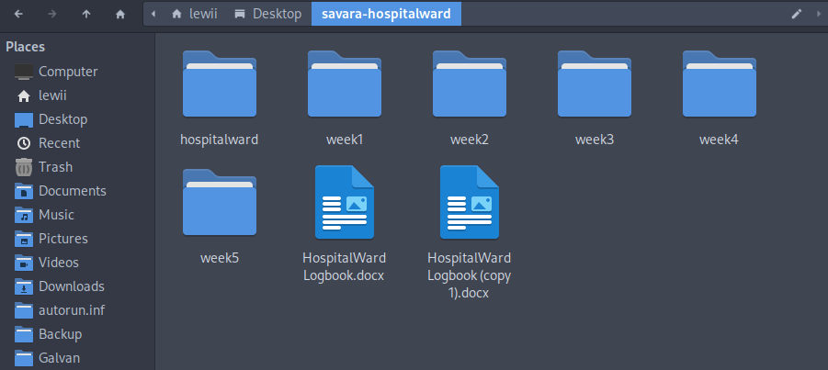
Folder structure on the project folder

Figure 4:

Login.php showing the password authentication code

Figure 5:

Student Reflection
This week I built the full authentication system. The register.php page collects name, email, and password, validates the input, checks for duplicate emails, then stores the account using PHP's password_hash() function so passwords are never stored in plain text. The login.php page retrieves the user by email and uses password_verify() to check credentials. PHP sessions store the logged-in user's ID and name.

Week 5: Database Integration and CRUD Operations

Required Evidence

Dashboard at phpMyAdmin for MySQL

Figure 1:

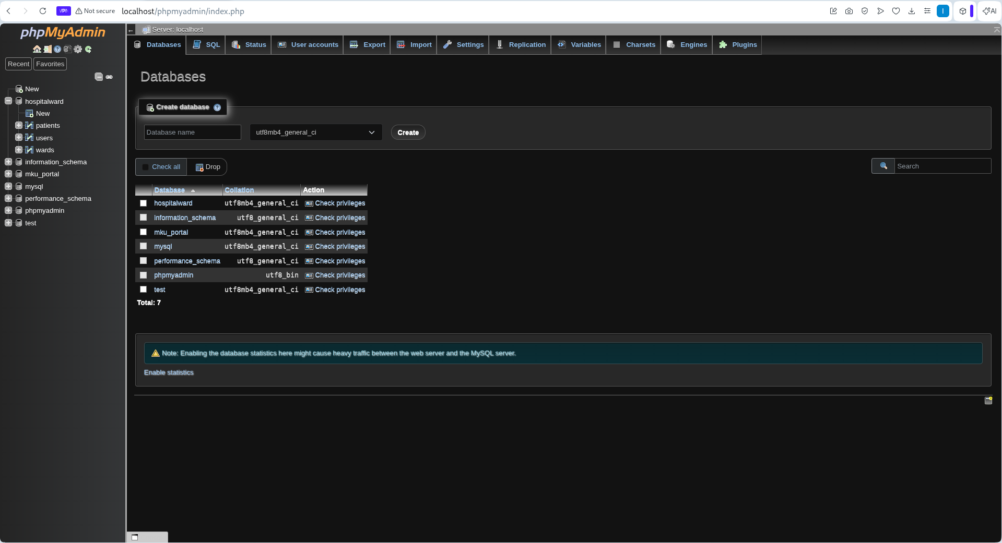
Database creation

Figure 2:

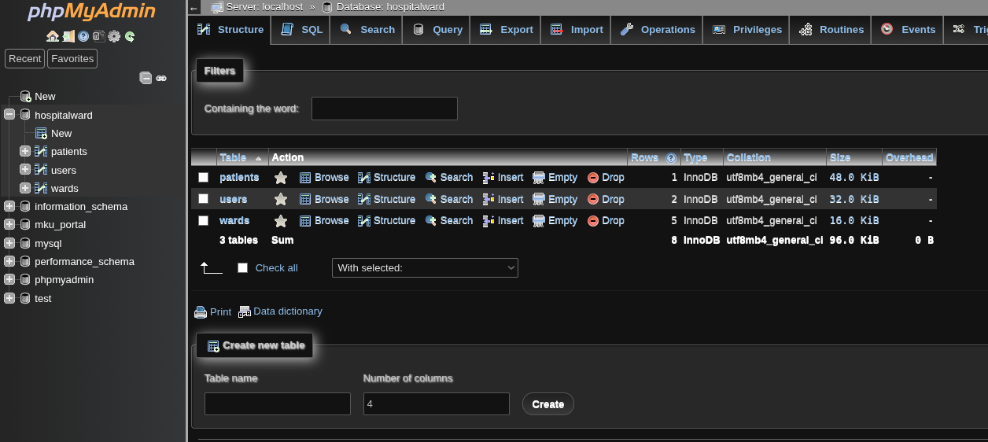
Tables for hospitalward created

Figure 3:

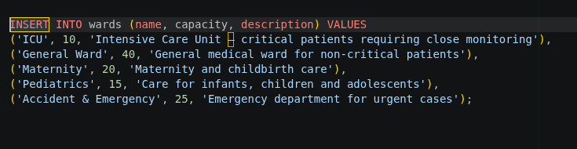
Ward table has columns for data

Figure 4:

Database connection code using PDO

Figure 5:

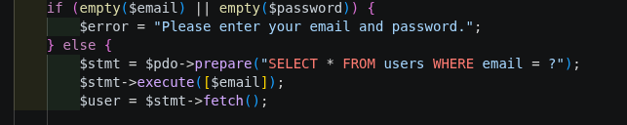
User data is fetched from the db for authentication

Figure 6:

Student Reflection
This week I connected the full system to the MySQL database. The add-patient.php page takes patient details (name, age, gender, ward, diagnosis, room number, admission date, and notes) and inserts them into the patients table using a prepared PDO statement. The dashboard.php page retrieves all patients for the logged-in user using a JOIN between the patients and wards tables. I also implemented discharge (UPDATE) and delete (DELETE) operations.

Week 6: CRUD Operations

Required Evidence

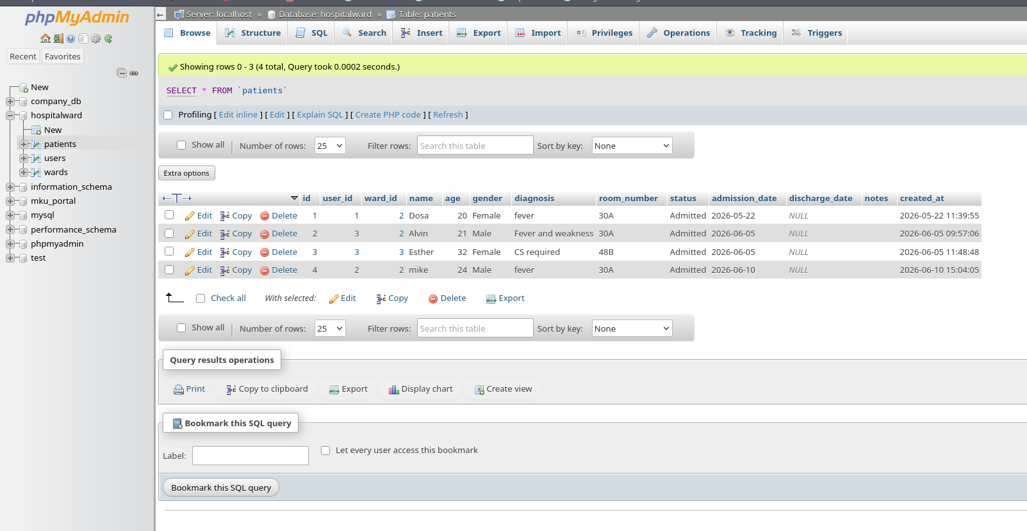
Database with all tables added

Figure 1:
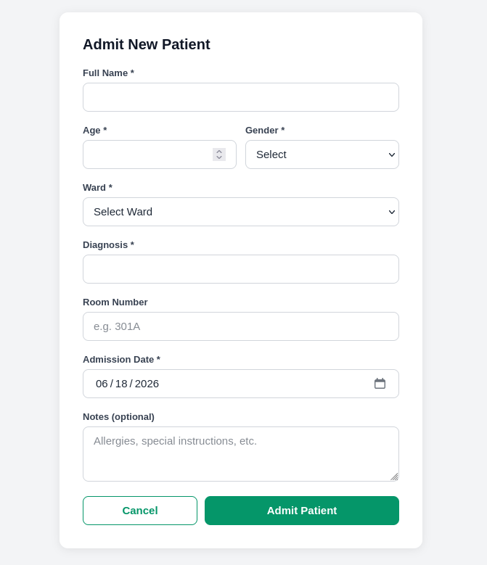
The add patient CRUD operation

Figure 2:

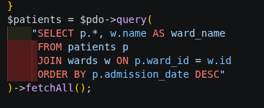

Fetch CRUD operation to view patients

Figure 3:

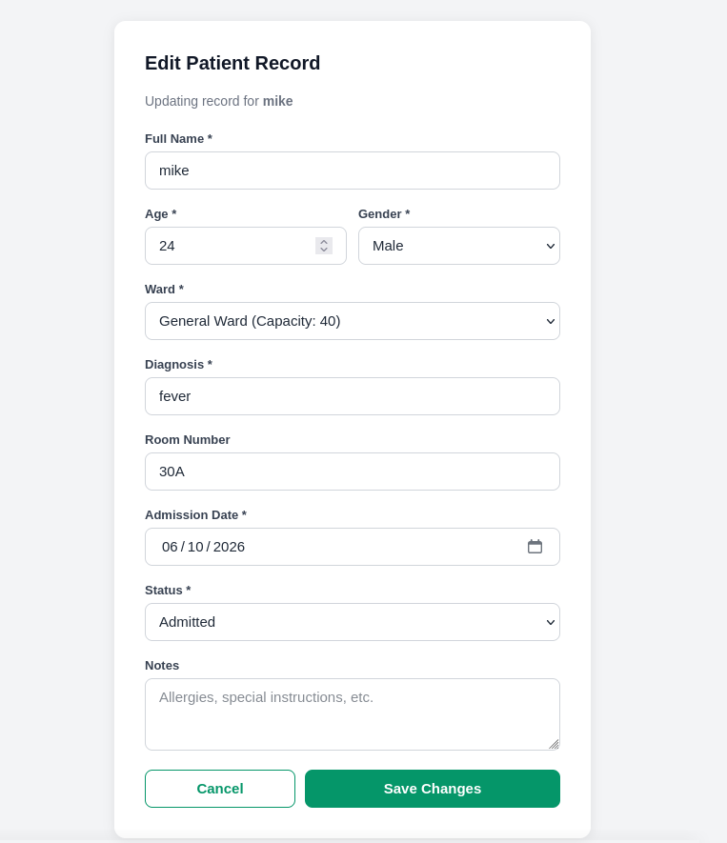
Updating patients data

Figure 4:

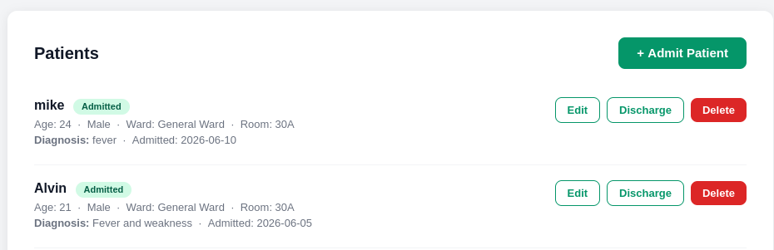
The patients record can be deleted

Figure 6:

Student Reflection
This week I studied on CRUD operations and implemented them in my Project. The add, delete, update, and so on are used to admit new patients, update their conditions and even delete records if necessary. The operations are linked to the database via the pdo to be able to perform the operations in the database too. Databases handle all user data in a web app.

Week 7: User Authentication and Session Management

Required Evidence

User data is fetched from the db for authentication

Figure 6:

User data is fetched from the db for authentication

Figure 6:

User data is fetched from the db for authentication

Figure 6:

User data is fetched from the db for authentication

Figure 6:

User data is fetched from the db for authentication

Figure 6:

Student Reflection
This week I studied on CRUD operations and implemented them in my Project. The add, delete, update, and so on are used to admit new patients, update their conditions and even delete records if necessary. The operations are linked to the database via the pdo to be able to perform the operations in the database too.

